Nashwa Abdel-Ghaffar Abdel-Rahman

Personal Details: | Date of Birth: 2 May 1985  National ID Number: 28505022600109  Nationality: Egyptian  Gender: Female  E-mail: nashwa_elmaghrby@yahoo.com  Address: Assiut –Takseem el Hokokein  St no:2  .  Mobile: 01094727966  Home phone: 0932794418  Marital Status: Married
  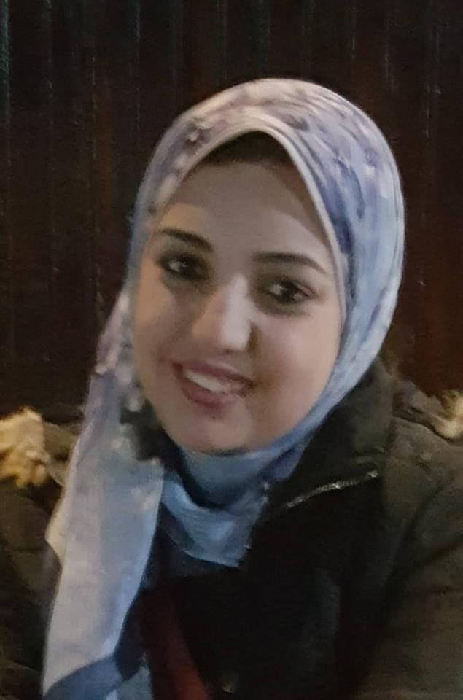
Qualifications: | - Bachelor of medicine and surgery September 2008.  - Master Degree in Medical Biochemistry and Molecular Biology 2017 with excellent degree.  - Pass the first part of MD in Biochemistry and Molecular Biology 2018.
Work Experience | - Sohag University Hospital : House officer: (1/3/2009-28/2/2010).  - Pediatric Department, Sohag University Hospital: Resident doctor , (1/4/2010-7/10/2012)  - Biochemistry Department, Faculty of medicine ,Assiut University: Demonstrator (8/10/2012 -30/9/2017)  - Biochemistry Department, Faculty of medicine, Assiut University: Assistant lecturer(1/10/2017-till now)

Education | - "Geneal Chromatography, New Tecnique of the HPTLC" workshop (9-10 December 2015): Metabolic and Genetic Disorders Unit (MGD), Faculty of medicine, Assiut University.  - "Evidence Based Medicine" workshop (18 January 2016 ): Quality Assurance unit, Faculty of medicine, Assiut University.  - "Infection Control" workshop (28-30 January 2016): Quality Assurance unit, Faculty of medicine, Assiut University.  - "Writing Medical reports" workshop( 16 February 2016): Quality Assurance unit, Faculty of medicine, Assiut University.  - "Updates in Metabolic, Molecular& Cytologenetic Disorders" Conference  (29-30 March 2017): Assiut University.  - "Cardiopulmonary Resuscitation (CPR)" workshop ( 11 June 2017) : Assiut  Medical Education and training center.  - "PCR from A to Z" workshop (10 February 2018): Metabolic and genetic (MGD), Faculty of medicine, Assiut University.

Interests | - Biochemistry &Molecular Biology.  - Laboratory working.  - Scientific research

References | References available upon request.

